# Development Assignment 1

Q1)

Design Diagram:

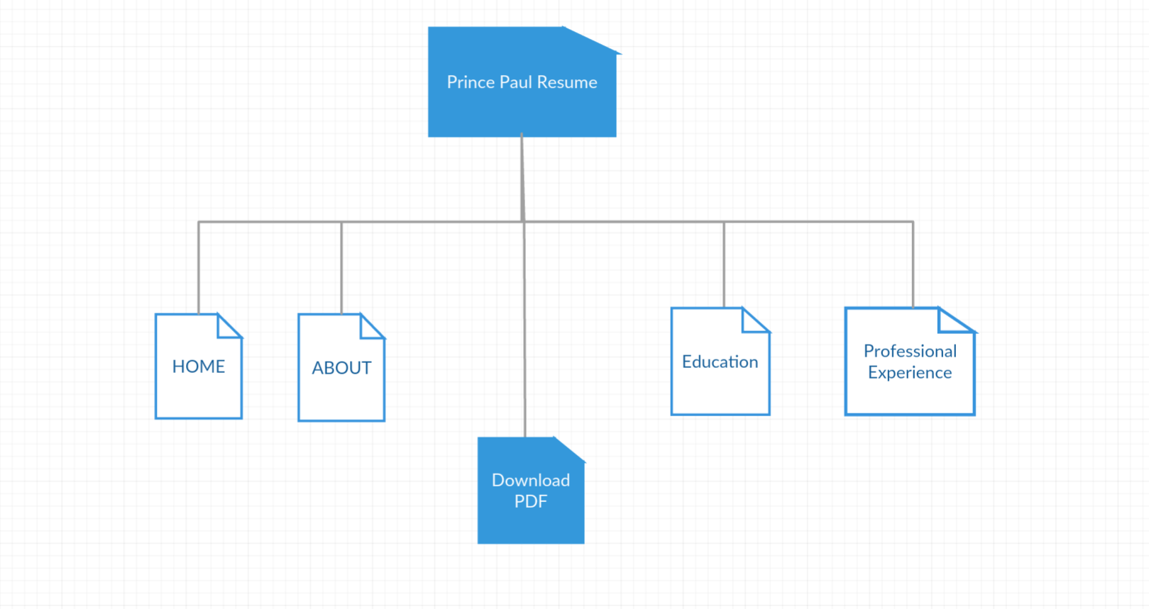

Q2) Content List:

* **prince.html**-is the main html file located in the folder.
* **resume.css**-is the CSS file for prince.html located in the folder
* **img folder**: contains the all images required for webpage(dp.png-header photo,bck.png-background image)
* The website is designed to be responsive
* A button is added “download pdf” that enables downloading resume-”resume.pdf”
* Java script is used in the buttons on click events such as click event on ABOUT button brings us content of about.

Q3) Please check attached file for code.

Q4)

Screenshot of site code validation:

HTML Validation:

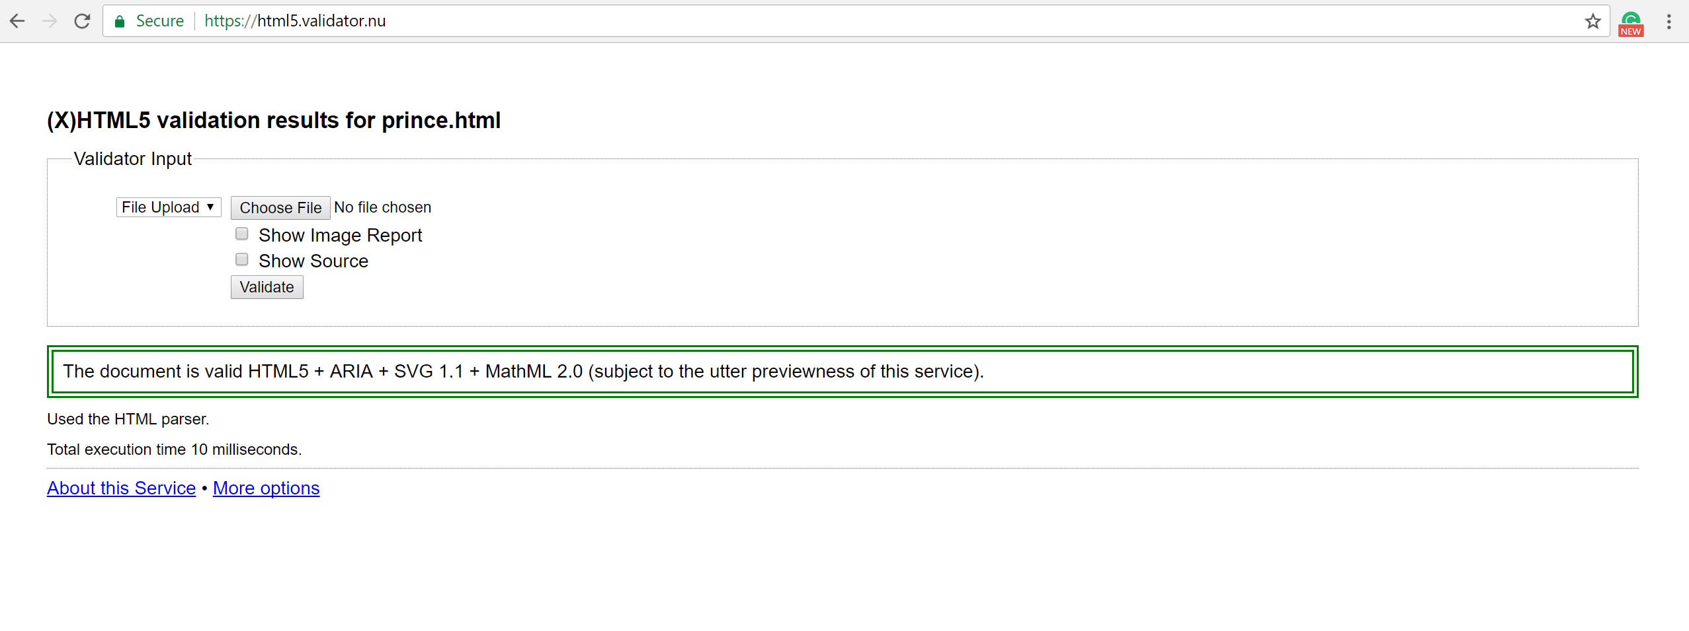

CSS Validation:

